Maris

Clear Cooperation Policy
As the implementation deadline of April 28, 2020 neared for the NAR 8.0 Clear Cooperation Policy and MARIS members, multiple communications were distributed. Thank you for your diligence in staying current and adjusting to the new policy. Our staff appreciated all of your feedback during this process. MARIS has worked diligently to address any issues as major systems changes had to be undertaken and adjustments were made due to Covid-19.
Our staff has collected an updated list of frequently asked questions and the most current information on the Clear Cooperation Policy below. If a link to a different blog article brought you here, it may have been outdated. Please take a moment to familiarize yourself with the information contained on this page. If you have further questions you can reach out to support@marismls.com.
To report in confidence a potential violation of the Clear Cooperation Policy, please send a photo or screen capture along with date, time, and any pertinent supporting information to compliance@marismls.com.
Updated: January 26, 2022 - All of the information on this page has been appropriately updated to match the policy as it stands today. Previous versions are available at the bottom of this page.

- What is NAR 8.0 Clear Cooperation Policy?
- When did CCP go into effect for MARIS members?
- Does CCP modify MARIS rules on listing entry?
- What if I don’t use the address of the property or someone else posts about it?
- Will MLS Exemptions still be allowed?
- When do I use the new Marketing Options Form?
- Why did MARIS introduce two new statuses?
- How does CCP affect my marketing plan and how I educate the homeowners about their options?
- Are members required to close listings that are sold while in the Withheld and Coming Soon Status?
- My listing is in Incoming. Doesn’t that comply with the Clear Cooperation Policy?
- Why has MARIS introduced the Coming Soon Status?
- Does the expected active date in Coming Soon automatically make the listing Active on that date?
- Why can’t I change the Showing Yes/No in Coming Soon from yes to no myself?
- How does the field Showings YN affect ShowingTime?
- How do I add the Showings YN column to my Matrix results page?
- Does Coming Soon Replace Active?
- Why has MARIS introduced the Withheld Status?
- Are all listings subject to the Clear Cooperation Policy?
- Can a property go under contract while in Coming Soon or Withheld?
- How are you going to enforce or deal with violations of Office Exclusive and Withheld?

- What is NAR 8.0 Clear Cooperation Policy?
  - November 2019, the NAR Board passed MLS Statement 8.0, also known as the Clear Cooperation Policy. The Clear Cooperation Policy (CCP) was designed to support a more cohesive and collaborative marketplace — where professional REALTORS® belonging to a cooperative network (MLS) share listings with each other under a common set of rules.
    - The policy states: “Within one (1) business day of marketing a property to the public, the listing broker must submit the listing to the MLS for cooperation with other MLS participants."
      - “Removal or cessation of public marketing after the fact does not eliminate the obligation of entry into the MLS.”
    - Public marketing includes, but is not limited to, flyers displayed in windows, yard signs, digital marketing on public facing websites, social media, brokerage website displays (including IDX and VOW), digital communications marketing (email blasts),multi-brokerage listing sharing networks, and applications available to the general public."
- When did CCP go into effect for MARIS members?
  - April 28, 2020.
- Does CCP modify MARIS rules on listing entry?
  - Yes. MARIS rules allow up to 5 business days to enter a listing as Active, Coming Soon or Withheld. However, if a listing is publicly marketed (i.e. sign in yard, email blast, etc.),the "one business day" requirement of CCP overrides and the property cannot be Withheld.
- What if I don’t use the address of the property or someone else posts about it?
  - The CCP simply states “marketing a property to the public”. It does not specify by whom or to what extent the property is identified. Any photo or description of the property (with or without address) that is designed to inform the public that a listing exists will be interpreted as public marketing. Please work with your service providers such as photographers, stagers, inspectors and even your sellers to clearly outline your marketing plan so the Clear Cooperation Rule does not trigger required entry into the MLS as a visible status before the home is market ready.
- Will MLS Exemptions still be allowed?
  - No, by introducing the Withheld Status to provide for Office Exclusive listings, MARIS has effectively replaced the MLS Exemption policy to ensure members are able to comply with CCP. MARIS has removed the MLS Exemption form and introduced a Marketing Options Form.
- When do I use the new Marketing Options Form?
  - The new form is only required if the listing will be Withheld but may be used with every new listing at broker discretion. It is not necessary to update the form if a listing progresses to a new status (i.e. Withheld --> Coming Soon).
- Why did MARIS introduce two new statuses?
  - MARIS is providing these statuses as part of our local implementation of CCP. These statuses are designed to ease the burden of tracking office exclusive listings and allow maximum flexibility for competitive marketing practices controlled by the brokerage in consultation with their clients.
- How does CCP affect my marketing plan and how I educate the homeowners about their options?
  - Each listing and seller have unique needs. Listing agents can customize their marketing plan by choosing a starting point or even progressing in steps through different statuses. Please consult the Marketing Options Form for more information. This form can be used to communicate in clear terms to the seller the status options to market a property.
- Are members required to close listings that are sold while in the Withheld and Coming Soon Status?
  - Yes. A listing that is sold in any status must be entered as closed. All information required for closing a property must be provided for comp only purposes. If publication of listing information is a concern due to non-disclosure, please ensure you mark “internet=no” when you close the listing.
- My listing is in Incoming. Doesn’t that comply with the Clear Cooperation Policy?
  - No. The term Incoming Status is a description of listing input, not an actual MLS status. Think of it as “partially input”. Incoming does not count as Withheld, Coming Soon or Active. Other MLS participants cannot see Incoming listings, so information input in this “pre-release” form does not comply with the Clear Cooperation Policy.
- Why has MARIS introduced the Coming Soon Status?
  - Coming Soon is a quick and efficient way for MARIS members to comply with NAR Clear Cooperation Policy 8.0. It provides all professionals in the MARIS network with awareness of the listing — during which time the listing brokerage and home seller can work together to enact marketing strategies, get work completed on the home, have professional photography completed, etc.
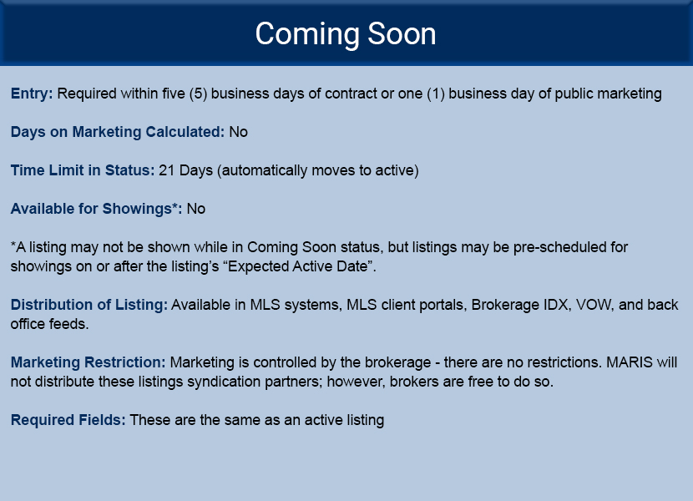This image has been updated to comply with the current policy regarding Coming Soon status.
    - Coming soon listings are distributed to brokerage IDX and VOW unless marked “internet no” but do not feed to Realtor.com, Trulia, etc. from MARIS. They are also available in back office feeds for internal brokerage products.
    - A broker may distribute their listing as they wish while in the Coming Soon status. There are no MLS restrictions on public marketing (Coming Soon signs, Posting to Websites or Portals, FB listing sharing networks, etc.) as this status is viewable by all MARIS members and complies with CCP. Advertising does not trigger a requirement to move a listing from Coming Soon to Active.
    - DOM does not accrue in Coming Soon.
    - The maximum time allowed in Coming Soon status is 21 days.
    - Showings are not permitted while a listing is in Coming Soon status. However, showings may be pre-scheduled in ShowingTime to take place on or after the listing's "Expected Active Date".
- Does the expected active date in Coming Soon automatically make the listing Active on that date?
  - Yes; a listing will automatically go active on a listing's "Expected Active Date", so it is important to make sure that this date is accurately entered.
- Why can’t I change the Showing Yes/No in Coming Soon from yes to no myself?
  - Showings are no longer permitted while a listing is in Coming Soon status. As a result, the Showings Yes/No drop-down option is no longer available on a Coming Soon listing. Please refer to this blog for further clarification on this update.
- How does the field Showings YN affect ShowingTime?
  - The Showings Yes/No action is no longer be available; however; ShowingTime will allow showings to be pre-scheduled on a listing's "Expected Active Date". It is crucial that this date is accurately entered as the listing will automatically go Active on the entered "Expected Active Date".
- How do I add the Showings YN column to my MATRIX results page?
  - To add a column, left click on any column heading when your cursor changes to a 4-sided arrow, and select “insert a column.” You can then select Showings YN from the available list of options. See the video below on how to do this:
- Does Coming Soon Replace Active?
  - No. Active is still the widest possible distribution of a listing.
- Why has MARIS introduced the Withheld Status?
  - CCP does not prohibit Office Exclusives. “Office Exclusive” listings are an important option for sellers concerned about privacy and wide exposure of their property being for sale. In an Office Exclusive, promotion within the listing brokerage, with clients of the brokerage (such as those under a buyer’s agency) and one-to-one communication with Realtors outside of the brokerage is not considered public advertising.
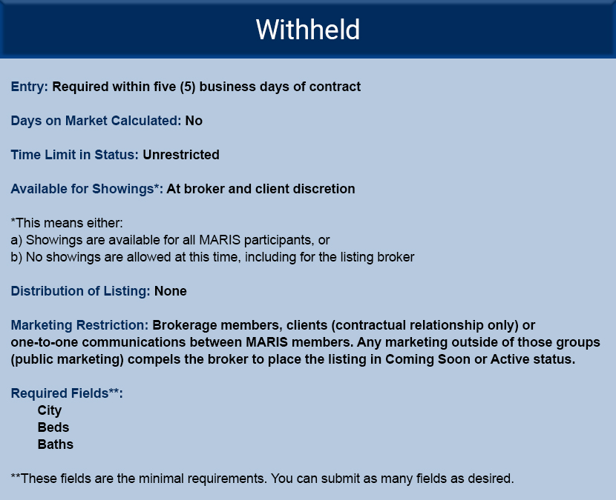

    - Minimal MLS entry is required for this status
    - Withheld listings are only viewable by the listing brokerage and MLS staff
    - DOM does not accrue in this status
    - There is no time limit on this status
    - Withheld listings may be shown and sold.
    - If sold, a withheld listing must be recorded accurately and completely for comp purposes but does not feed outside of MARIS systems.
    - Public marketing of the property by the brokerage, seller, stager, photographer, etc. will trigger the requirement that a Withheld listing be moved to Coming Soon or Active within one business day.
    - Changing a Withheld listing to any other status will make it visible to membership and cannot be undone, thus Withheld listings are only required to be marked CLOSED (as opposed to Pending or AUC).
    - Withheld listings do require that the Marketing Options Form be completed, signed, and kept with brokerage listing paperwork.
- Are all listings subject to the Clear Cooperation Policy?
  - No. Only listings of the designated types of property are required to be submitted to the service.
    - COMMERCIAL, INVESTMENT, INDUSTRIAL & DISPLAY PROPERTIES ARE PERMITTED FOR INSERTION AT THE LISTING BROKER’S OPTION.
    - Investment Property Defined - Investment Property, to include any residential property which consists of 5 or more units within a common structure and sharing a common tax id; any package, combination or bundle of separate parcels or structures intended to be marketed and sold together as a whole; or any property managed on behalf of an owner by a property manager.
    - Please consult the MARIS rules and regulations for more information on listing requirements.
      - One Party Listings must comply with Clear Cooperation if publicly marketed.
- Can a property go under contract while in Coming Soon or Withheld?
  - Yes. MLS rules govern the listing of property and helps create a fair and productive market for all Participants and their clients. The NAR Clear Cooperation Policy mandates that properties publicly advertised by Realtors must also be listed in the MLS they participate in. Showings are not permitted while a listing is in Coming Soon status. Contract presentation and acceptance is somewhat of a separate issue from MLS listings as long as a member is abiding by all governing regulations. Presentation of contracts and the fair ethical treatment of cooperating Realtors, their clients and unrepresented consumers are governed and enforced both by:
    - Applicable state license law and real estate commission
    - Realtor Associations via the Realtor Code of Ethics.
- How are you going to enforce or deal with violations of Office Exclusive and Withheld?
  - The new statuses will be enforced in the same manner all MARIS rules and regulations are. The enforcement policy can be found in Section 10 of MARIS rules and regulations. MARIS will monitor the use or abuse of the new statuses and work with board of directors to craft more stringent enforcement policies if needed. PLEASE NOTE:
    - Failure to take corrective action in a timely manner (even with an educational notice) can result in a substantial fine.
    - Because the NAR rule clearly states “within one business day of marketing the property to the public”, simply removing a sign or taking down a social media post does not stop the obligation of entry into the MLS.
Version 06112021

Bay Area Web Development

